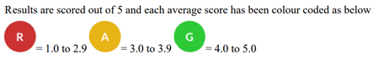
Parent –
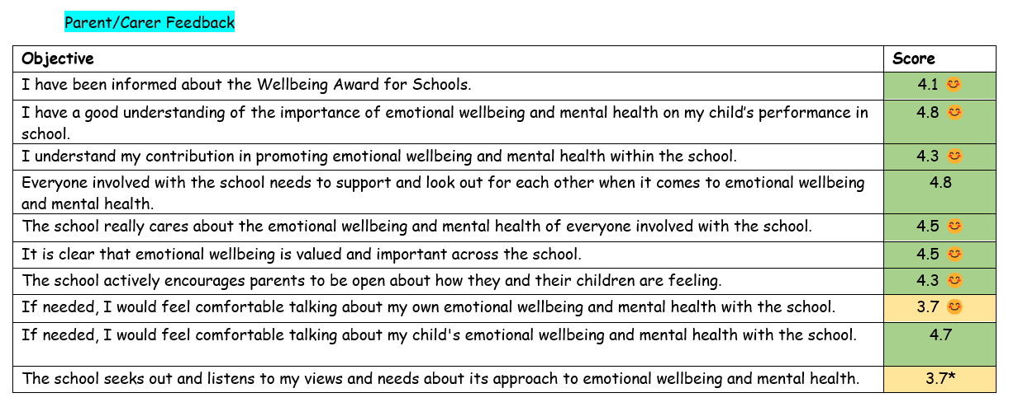
Pupil –
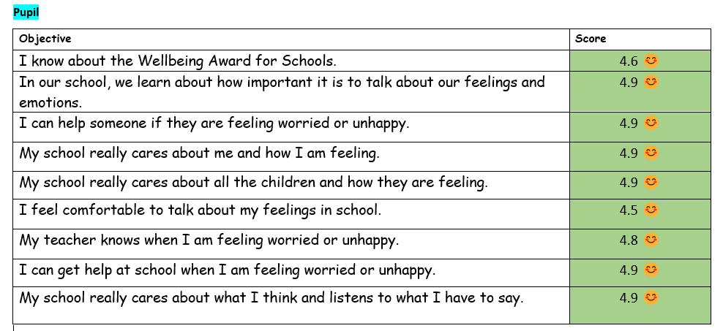

Staff -
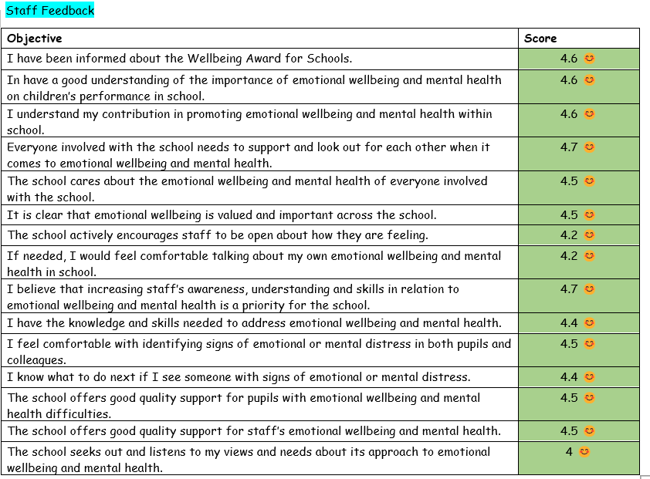
- Improved score
* - Lowered score
No symbol means score stayed the same.

