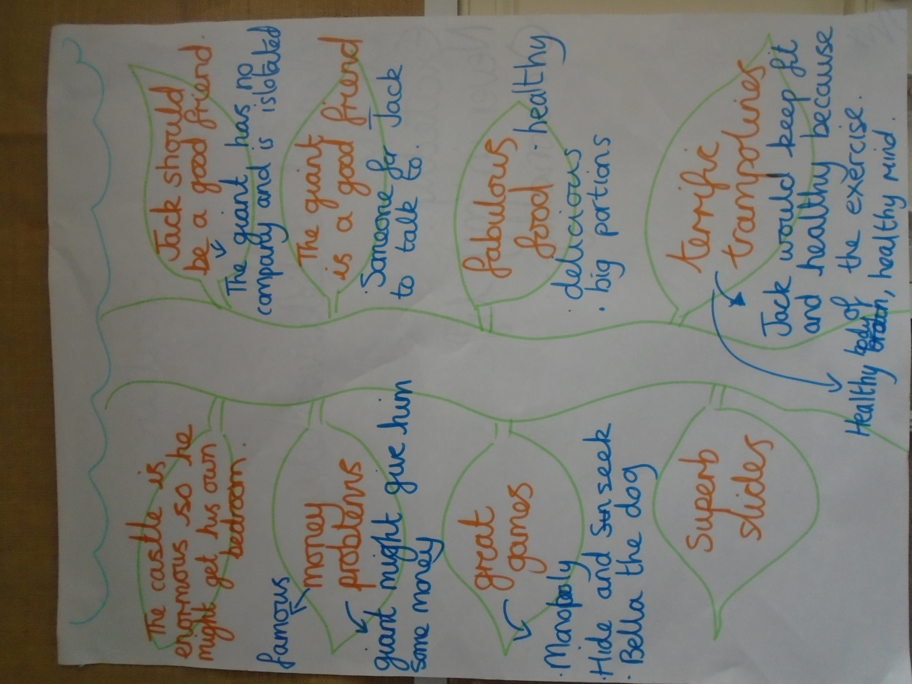

Persuasive Words and Phrases
I think that… You must consider… I feel that…

Surely… It would be very unfair… I think…

How would you feel if … I know that … In summary…

To summarise…

Words Bank
dreadful magnificent filled with excitement superb

about time doorstep company isolated loneliness

friendless entire great climb beanstalk

beautiful would should could don’t wouldn’t

Conjunctions
and but if so because when or

Example of our Expectation

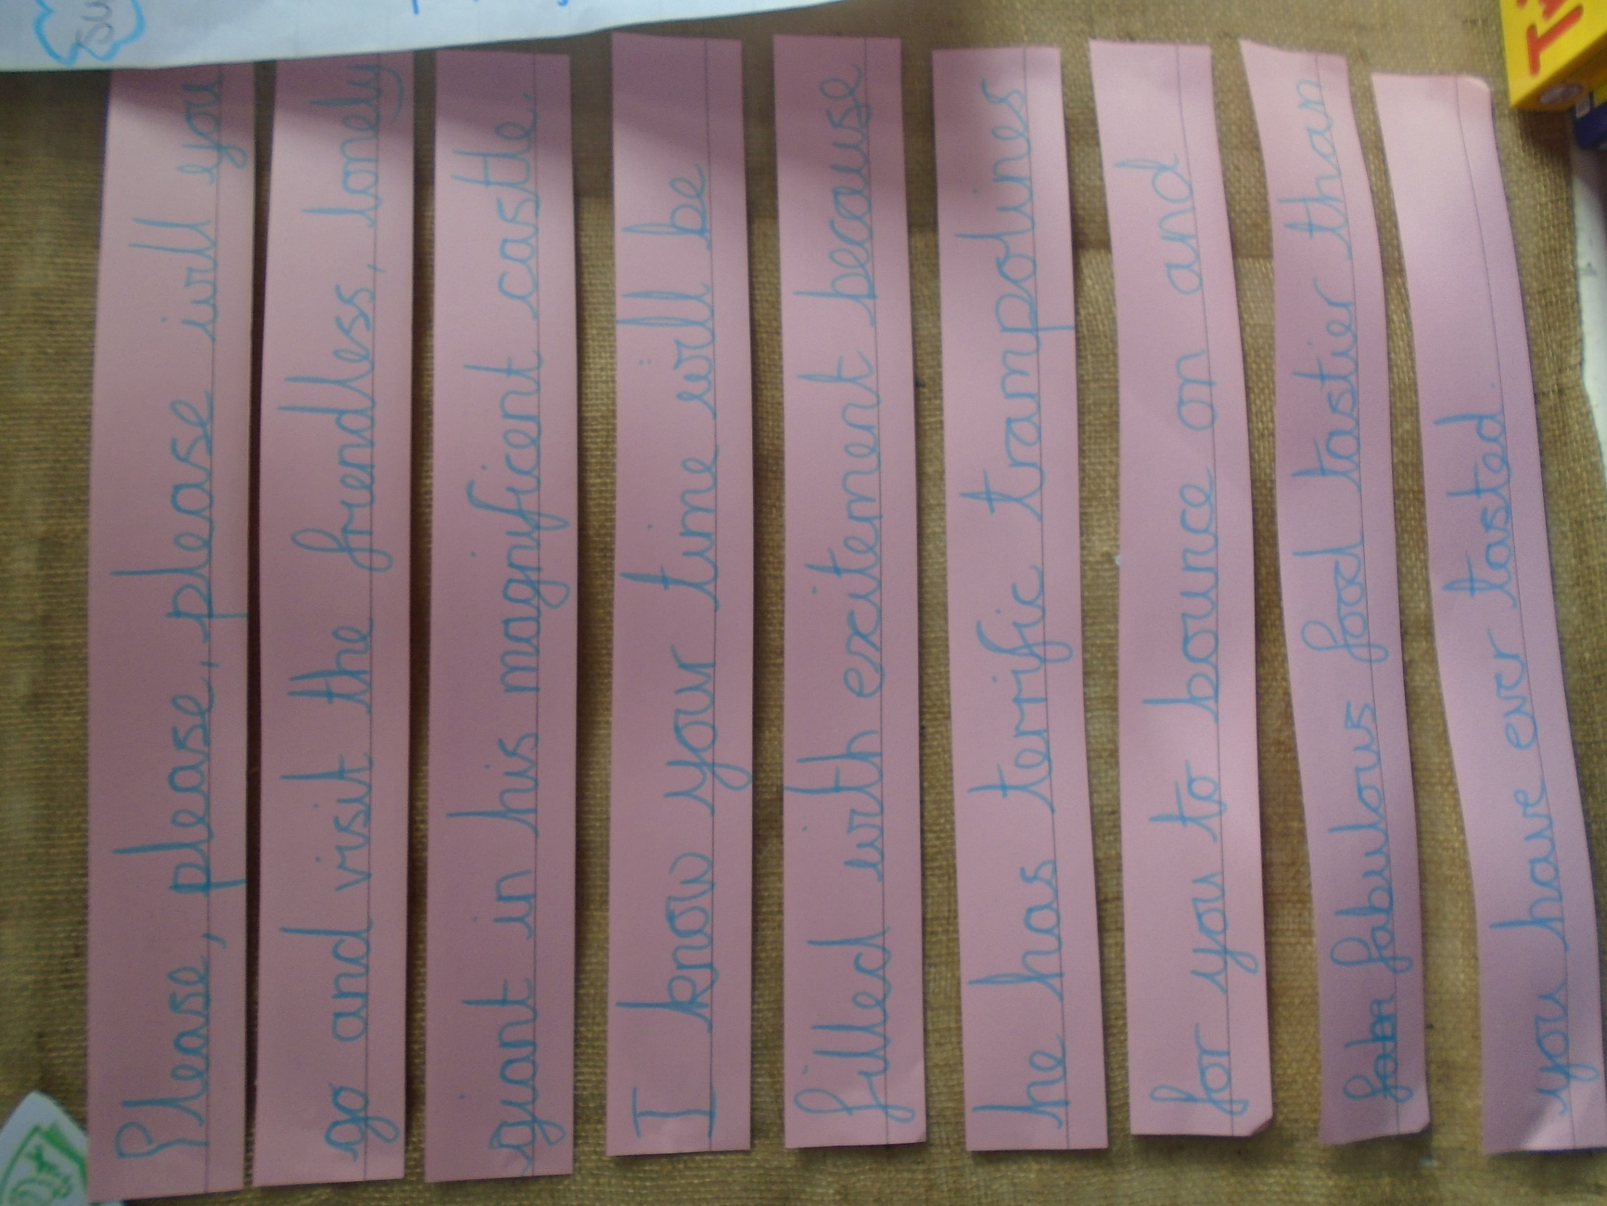

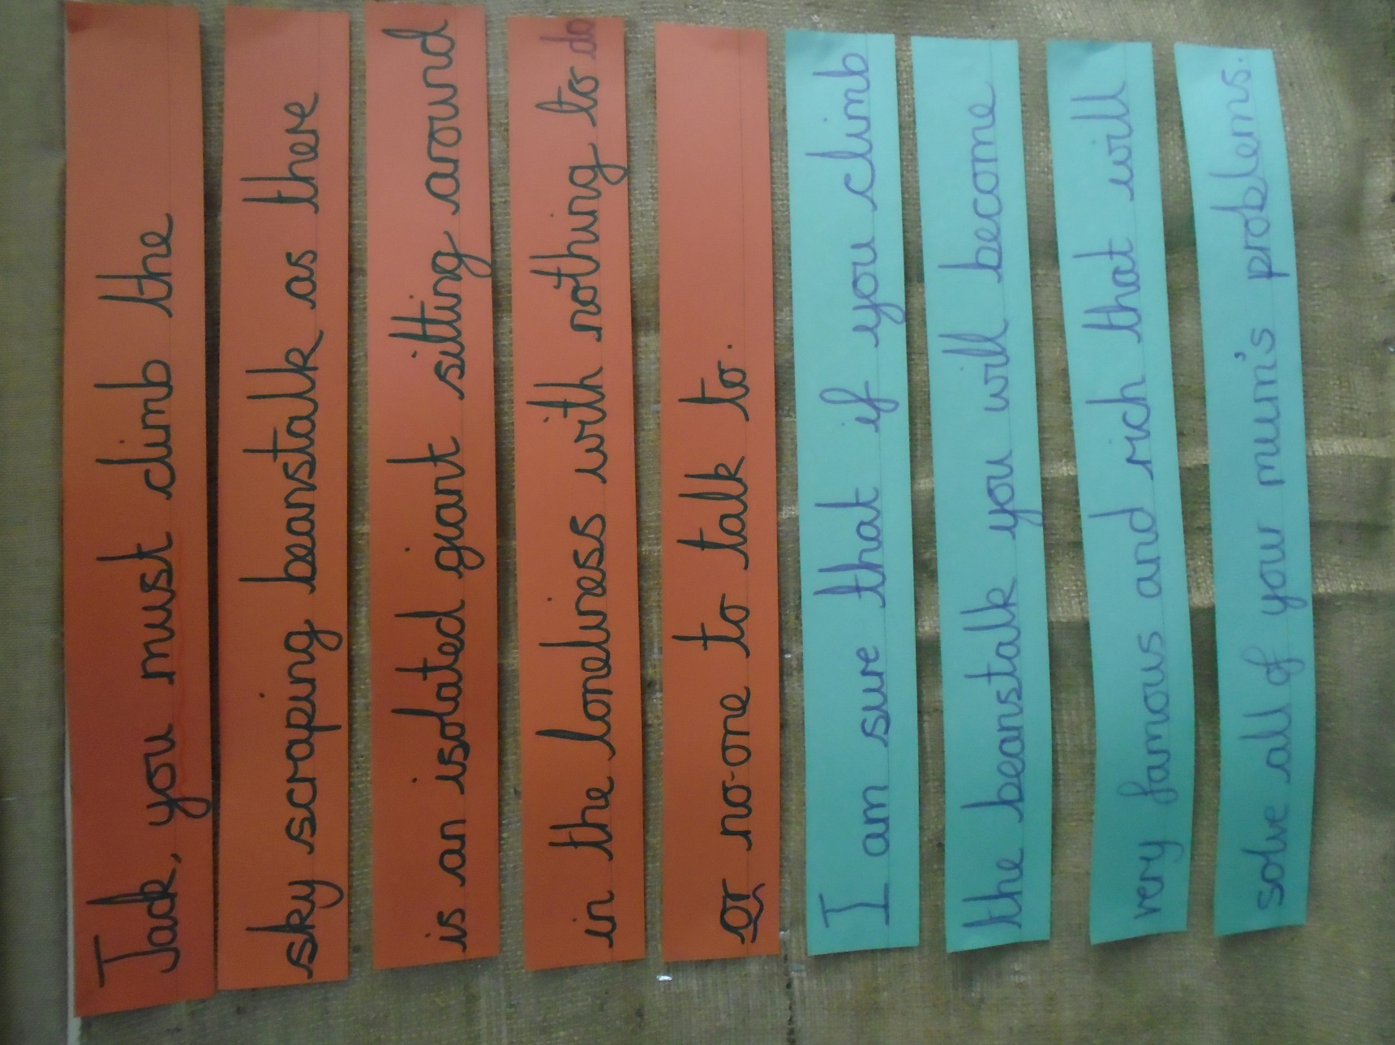

Success Criteria
The children can refer to this when writing their letter. Once they have finished their letter they can tick and write what they have used.
Success Criteria | I have used…
A range of punctuation:
. , ? ! and CL (capital letters)

Different sentence types:
Statements, commands, questions and exclamations

Expanded Noun Phrases
E.g. the sky-scraping beanstalk
Friendly, isolated giant

Conjunctions
and, if, so because, but, or when

Persuasive Language

Suffix words
Friendly, friendless, loneliness, excitement, dreadful

