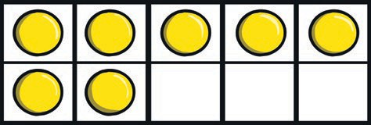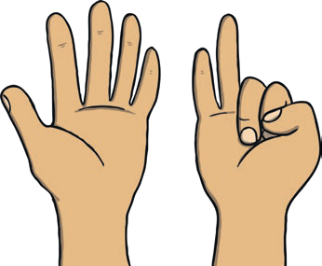

**All About Number 7 Number Formation Activity**

How many fingers are being shown?

How many counters are in the ten-frame?

How many rabbits can you see?

How many balls are there?