**All About Number 3 Number Formation Activity**

**3 3 3 3 3 3**

**3**

**3**

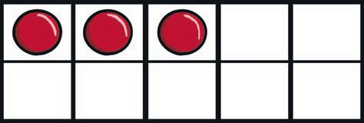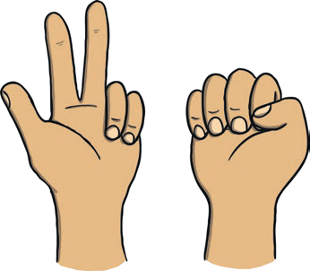

How many fingers are being shown?

How many counters are in the ten-frame?

How many boats can you see?

How many dogs are there?