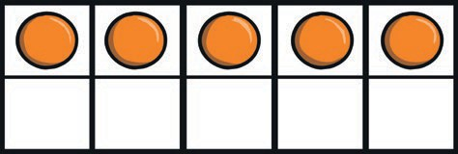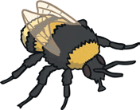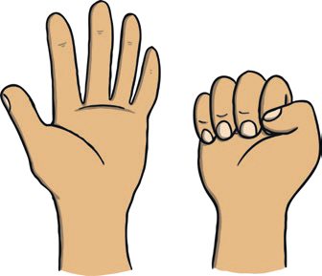



**All About Number 5**

**Number Formation Activity**

**5 5 5 5 5**

How many fingers are

How many counters are in the

being shown?

ten-frame?

How many teddy bears are there?

How many bees can you see?