History in our School – Autumn Term 2021

We have had an exciting start to our History curriculum this term, including a celebration of Black History Month.

Year One learnt about the History of Toys, comparing our grandparents’ toys with toys nowadays, looking at a selection of old wooden toys. The children also made their own cup and ball toy.

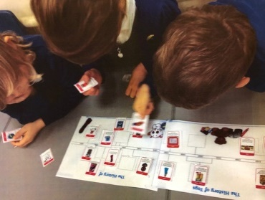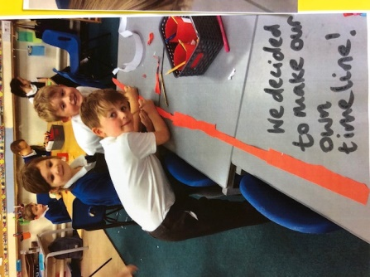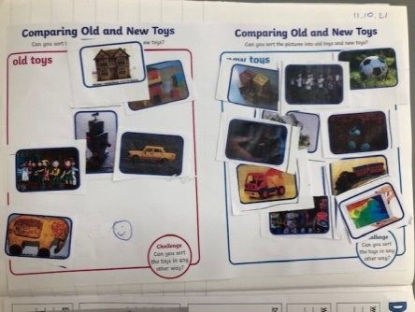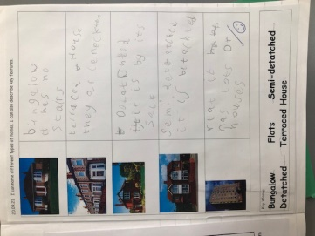

Year Two have also been creating time-lines of significant individuals and focussed on Christopher Columbus as their key individual. They sequenced the events in Christopher Columbus’ life and created a fact file about him.

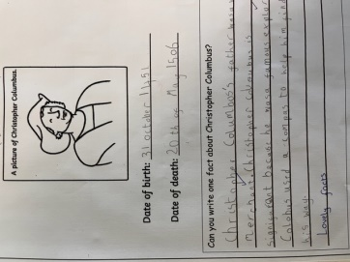

The whole school celebrated Black History Month on Monday 18th October. Where we started with a special assembly from MEAS about how important diversity is and about how special everyone is. Then teachers in each year group prepared lessons and activities based on significant Black individuals and events in History.

Children learnt about why we celebrate Black History, what racism means, why it is important to recognise black people from history and recent history. They learnt about significant black individuals including Rosa Parks, Marcus Rashford and Mo Farah. And they appreciated black artists and endeavoured to mimic some of their artwork. Here is a selection of photographs from the day:

