Modern Foreign Languages (MFL) in our school – Autumn Term 2021

It has been wonderful to provide MFL again from the beginning of September and the children have been immersed in French, Spanish and Global learning.

Unfortunately this term we have not been able to host a Chinese language teacher which we normally do each year. Hopefully the New Year will see us being able to re-introduce Mandarin Chinese into the curriculum again.

Children in F1 have surprised us with their enjoyment and ability in their weekly French lessons with Mrs Clark. They have enjoyed using finger puppets to help them when saying their greetings. They have learnt numbers 1 to 5, colours and animals. They have loved singing and dancing to Sur le Pont D’Avignon and learning new rhymes and songs.

Children in F2 have also been enjoying their weekly French lessons with Mrs Clark. They have learned greetings, parts of the face and body and singing songs and rhymes.

Children in Y1 and Y2 have been learning Spanish with an All About Me topic, including family members. The children have all learnt about the countries where Spanish is spoken and made a flag for their chosen Spanish speaking country. They have also been learning about Spanish traditions and customs.

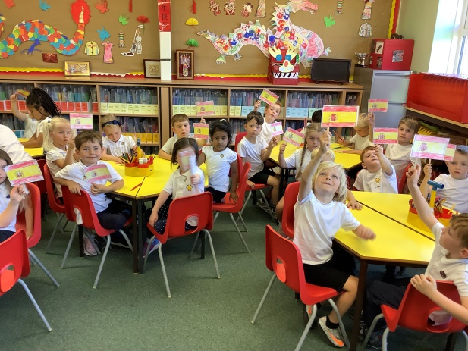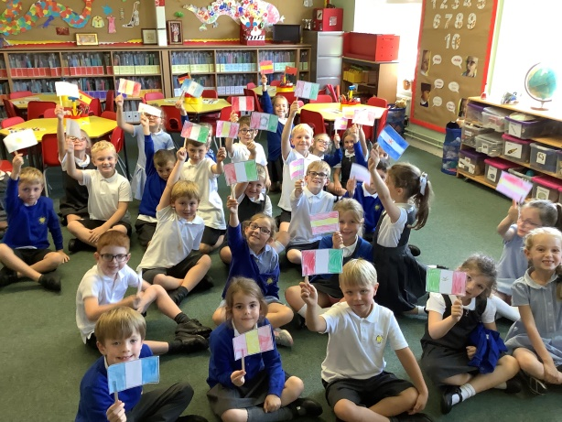

On Monday 27th September, we celebrated European Languages day across the whole school. We started with an assembly where Year 2 children read out facts about European Languages and then the whole school sang Frere Jacques in 3 different languages. Teachers in all classes prepared lessons about a chosen European country, teaching children about the customs, culinary delights, dances, flags and language(s) spoken there.

European Languages Assembly & Classroom Activities:

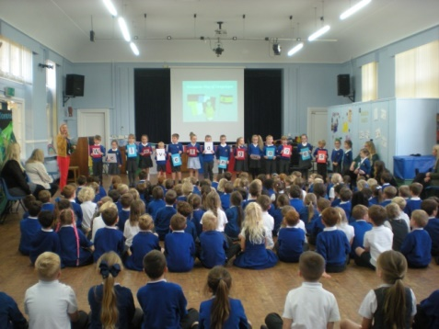
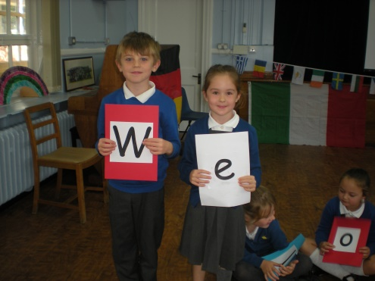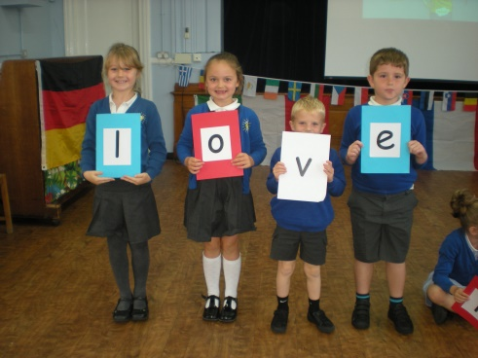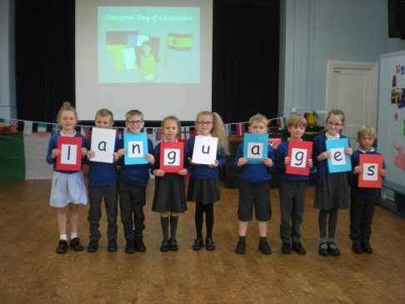

Year 1 learnt about Belgium & Poland:
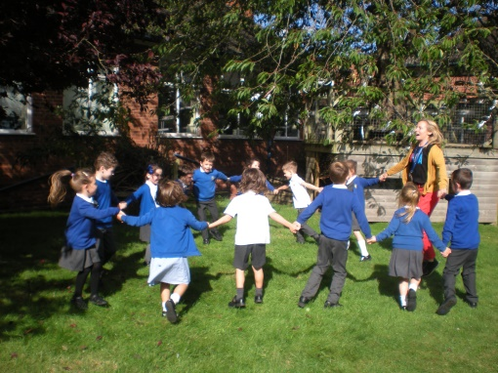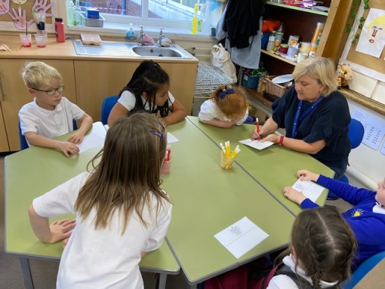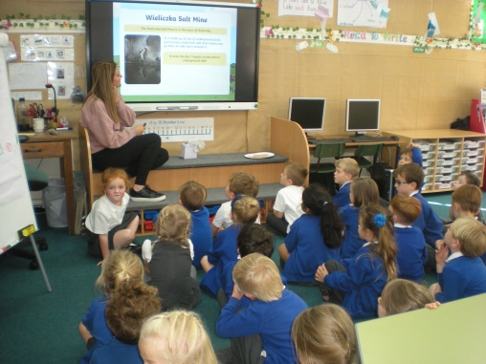
Year 2 learnt about Germany and Greece:
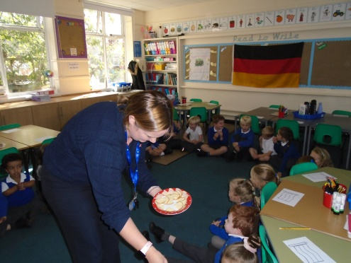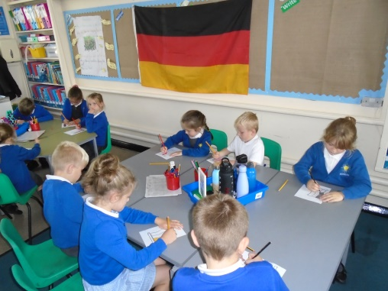
F2 learnt about Wales and Italy:
