Geography in our School – Autumn Term 2021

In Year One, the children have learnt their own address, and about their locality, talking about where they live and the type of house they live in. They have been developing their mapping skills, by planning the playground and classroom using aerial photographs.

Year 2 have been improving their knowledge of our planet; learning about the oceans and continents and positioning them correctly on their own ‘globe’. They have also named the capital cities of the countries in the United Kingdom.

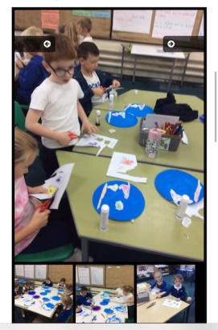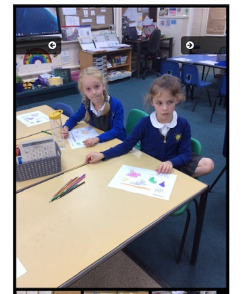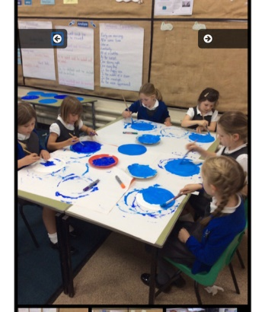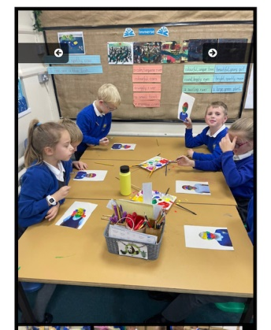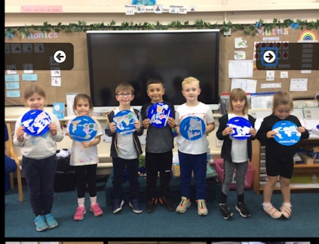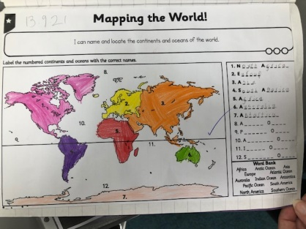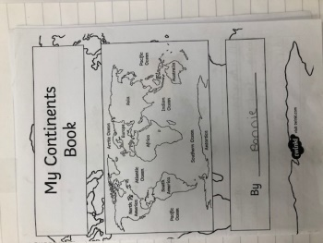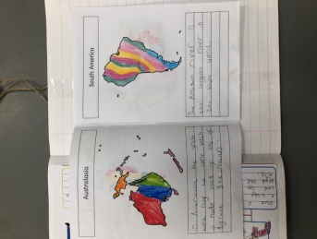

On Monday 27th September, we celebrated European Languages day across the whole school, combining cross-curricular links with Geography, languages, Art, DT, Music and Dance. We started with a special assembly, where Year Two children presented facts about European Languages. Teachers in all classes prepared lessons about a chosen European country, teaching children about the customs, culinary delights, dances, flags and language(s) spoken there.

Below are photographs taken in all year groups throughout the day. The children thoroughly enjoyed the varied activities and the opportunity to learn about new countries and cultures.

Year 1 learnt about Belgium & Poland:
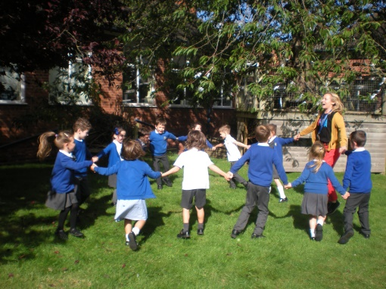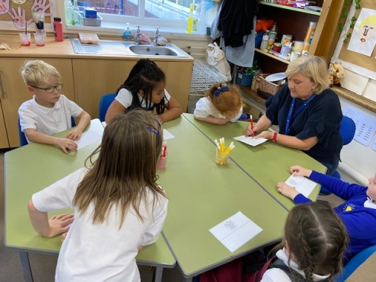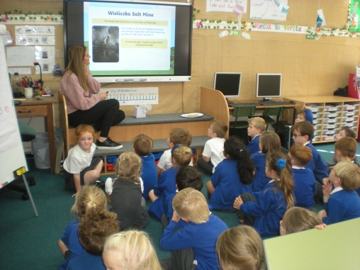

Year 2 learnt about Germany and Greece:
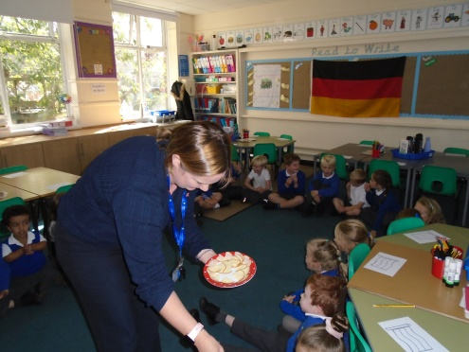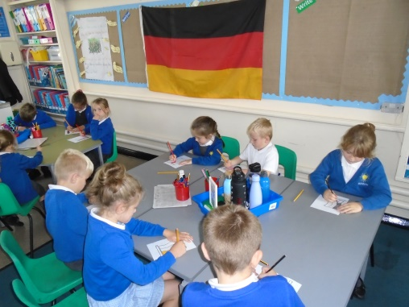

F2 learnt about Wales and Italy:
