Weekly tasks that should be ongoing:
Please read with your child at least three times a week using Bug Club online. The children should also click on the bug and answer the questions.
Also the children that have been in school this week should have received their spelling quiz please support your child to learn the words highlighted in yellow. Children are expected to spell these words by the end of Year 2
 | Focus | Activities to support children working below | Activities to support children working at expected
Writing | Jack and the Baked Beanstalk  This half term our literacy has been based around the story Jack and the Baked Beanstalk. The children received a letter from the giant (all resources below to support your child’s learning) asking Jack to visit him. We have completed a lot of work around this over the past few weeks. We have been encouraging the children to use persuasive language and conjunctions (and, because, if, so, but when).  Begin by reading the letter to the children asking them three reasons why Jack should climb the beanstalk. There are some examples from our working wall in the resource pack. Children should then write their ideas down onto the planning sheet see resource pack (Activity 1)  Following on from this the children are to write a letter to Jack persuading him to climb the beanstalk using the success criteria below. In school we focus on a paragraph at a time so this will give you four separate sessions. Model writing a paragraph and then get the children to write it independently. Once they have finished they can check their work against the success criteria to see what they have included.  Once the children have finished the activities enjoy the story together. This can be found under videos on google. | Activity 1  To think of three reasons jack should climb the beanstalk and complete the worksheet below drawing a picture and writing a simple sentence sounding out words carefully.  Activity 2  Children to write a letter to Jack consisting of a sentence for each reason. This can be split into three different sessions – a sentence each session. | Activity 1  To plan their persuasive letter to Jack. See attached sheet.  Activity 2  Children to write their letter to Jack to convince him to climb the beanstalk. Please see success criteria in resource pack (this is what we would like the children to include in their writing).  Activity 3  Edit their work checking for punctuation and spelling.

 | Activities to support children working below | Activities to support children working at expected
Maths | Daily count activities – support your child counting in 2’s, getting further each day.  Number bonds to 10  Practise your number bonds to 10 by playing the ‘Total of 10’ card game  Can you think of any new rules for playing this game?  Link to the ‘Total of 10’ card game:  https://www.youtube.com/watch?v=SD028NO-ZGc&list=PLWIJ2KbiNEyoBDc5yLJ4PaiaY3o5E5xCB&index=5&t  Telling the time to the half hour  Ask your grown up to draw a number line from 1-12 and cut out an arrow (this will be your hour hand). Each number represents an hour on the clock, so if the arrow points to 1 it is showing 1 o’clock. Position your arrow on different numbers and read out the time. Then put your arrow half way between 2 numbers. This represents half past, so if your arrow is half way between 2 and 3, it is half past 3.  Next draw a round clock and do the same with just one hand. Once you are happy telling the time with one hand, you can make a 2nd longer hand. This is your minute hand. Where should it point for o’clock? Where should it point for half past?  Link to video on telling the time to o’clock and half past:  https://www.youtube.com/watch?v=V32tRiEQ2AA  One more and one less  Get some raisins, grapes, cereal pieces. Place some on a plate. If the grown up with you says ‘one more’, add one more and say what number you have now. If they say ‘one less’, eat one and count how many you have left.  Ask a grown up to give you some toys. Count how many you have. Can you put out another group of toys so you have one more and then one less?  Build a tower with bricks. Can you build another tower with one more brick? Can you build another with one less brick? | Please see the additional links for arithmetic sheets that we would like the children to complete this week. Please encourage your child to show their working out even if they can do these in their head.  Missing Numbers  The children have started to look at missing numbers in a number sentence. We have taught them a rhyme to help them. Please help your child to learn the rhymes and then complete missing numbers in a number sentence up to 100. When the children are solving the problem they are to use the column method to support them. They have been taught how to adding and subtract when crossing the tens.  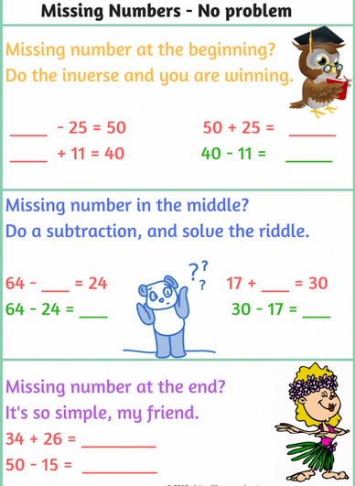  Time (o’clock, half past, quarter past and quarter to)  Why don’t you make your own clock and have a go at telling the time to o’clock and half past using just the hour hand. Once you are confident with that, have a go at telling the time to quarter past and quarter to.  Once you have tried it using just the hour hand, bring in the minute hand too.  Link to video on time (o’clock and half past):  https://www.youtube.com/watch?v=V32tRiEQ2AA&t  Link to video on quarter past and quarter to:  https://www.youtube.com/watch?v=86RbCwhdJSs&t  Challenge: telling the time to the five minutes

Reading Comprehension and Sounds to Learn
Depending on what bug club book band your child is on will depend on the comprehension they are required to complete. The comprehensions are uploaded on the website.
Children reading pink or red please read a book to your child and ask them questioning about the text.
Yellow/Blue | Green/ Orange | Turquoise/Purple/Gold | White/Lime
Bats |  | The Zoo Vet
Set 2 Sounds to Learn  Encourage your child to learn the sound and write words with this sound in.  ay – may I play  igh – fly high  ow – blow the snow |  | Set 3 Sounds to Learn  Encourage your child to learn the sound and write words with this sound in.  ew – chew the stew  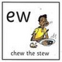  a-e – make a cake  i-e – nice smile

Science
Over the next two weeks we would like the children to plant two seeds in different containers with soil and keep a diary. One seed is to have sunlight and water. The other is to be kept in a dark place and not have any water. At the end of the two weeks the children are to compare to plants.

Spelling Ideas
Below are some ideas of how to support your child with learning their spellings.

