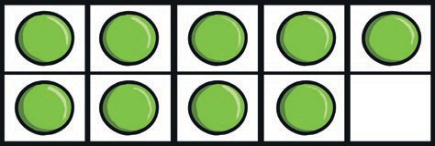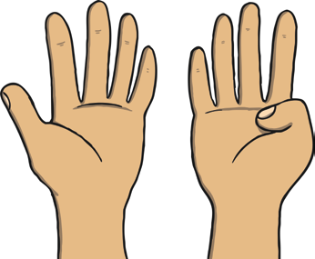

**All About Number 9 Number Formation Activity**

How many fingers are being shown?

How many counters are in the ten-frame?

How many balloons can you see?

How many cakes are there?